AUE-893 Autonomy: Science and Systems

Repository: https://github.com/rmerco-clemson/AuE893Autonomy.git

Commands for launching the applications

Robot Cleaner – grid logic
The following command will run the turtle simulation in order to execute the Robot Cleaner application following a grid patter to cover all the room:

> roslaunch assignment_01 turtlesim_grid_cleaner.launch

A rosbag file able to replay the Twist messages is in the folder bagfiles. A readme file is also provided.
Figure 1 shows the results of the simulation.

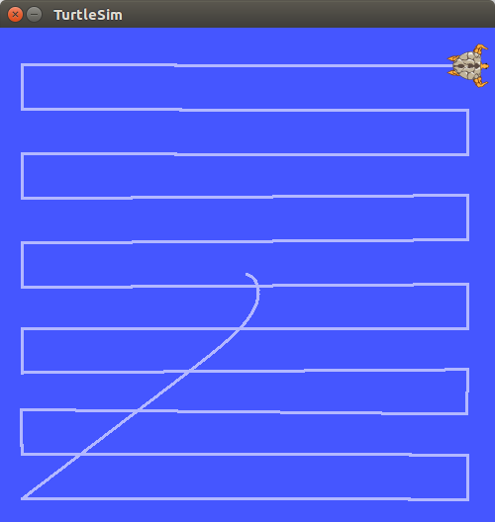
Figure 1: Robot Cleaner application: grid pattern

Robot Cleaner – spiral logic
The following command will run the turtle simulation in order to execute the Robot Cleaner application following a spiral patter to cover all the room:

> roslaunch assignment_01 turtlesim_spiral_cleaner.launch

A rosbag file able to replay the Twist messages is in the folder bagfiles. A readme file is also provided.
Figure 2 shows the results of the simulation.

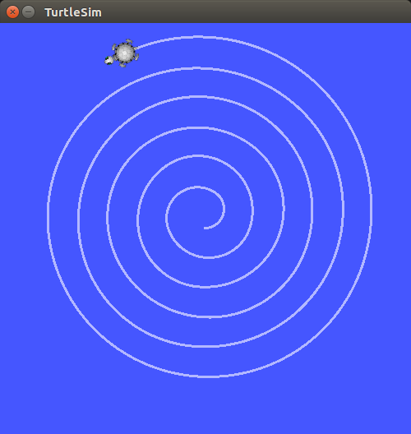
Figure 2: Robot Cleaner application: spiral pattern

Robot Cleaner – Gazebo grid logic
The following commands will run the same application of the turtle simulation in Gazebo. In particular in Gazebo has been reproduced the Robot Cleaner application following a grid patter to cover all the room. In this case two closed loop controllers are implemented:
- PD controller for controlling the forward speed of the robot during the cruse to the next point
- PD controller for controlling the orientation of the robot during the cruse to the next point

First of all the Gazebo world has to be launched:

> roslaunch assignment_01 ten_squares_gazebo_world.launch

After that the previous command is completely executed and Gazebo is correctly running, use the following command:

> roslaunch assignment_01 ten_squares_grid_cleaner.launch

Figure 3 shows a screen-shot of the simulation while it is running.
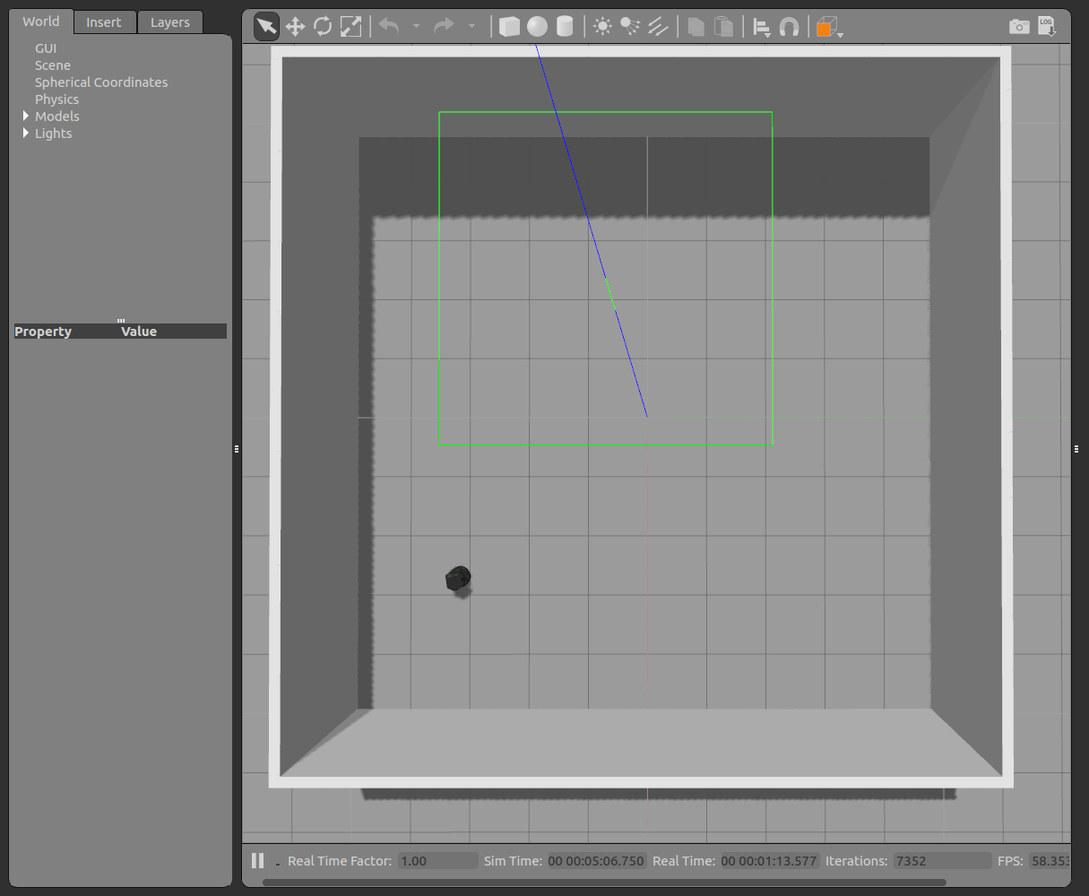
Figure 3: Robot Cleaner application simulated in Gazebo

Robot Cleaner – Real Turtlebot
The following commands will run the application in the real Turtlebot. This application will run the Turtlebot forward for 2 meters, then it will turn of 180 degree and then it will run back for 2 meters.

First of all the the roscore has to be started:

> roscore

Then the connection with the Turtlebot has to be created using:

> roslaunch turtlebot_bringup minimal.launch

After that the previous command is completely executed and a melody coming from the robot is heard in order to give you the feedback of the established connection, use the following command:

> rosrun assignment_01 turtlebot_real_back_and_forth.py

